BOOKENDS HOSPITALITY PVT. LTD.
Internal Operations — Regulatory Readiness Series
FSSAI Internal Food Safety Audit — Checklist Report
Ahmedabad Bakery Kitchen · 40 lines assessed · 18 ★ critical · 20 lines removed as not applicable
Outlet / Brand | Bakery Kitchen | Audit Date | 04/09/2026
Location | Karnavati PG, Ahmedabad. | Time Start – End | 09:00AM to 10:00AM
Business Category | Restaurant | Audit Type | Surprise
Auditor | Vishal Patel | Report Prepared By | Nikil Malaviya
Marking: Compliant — 2 marks Minor — 1 mark Major — 0 NA — not applicable, excluded ★ critical — marks count double
One rating per line. Every Minor or Major carries a remark in the ‘Remark / Photo’ column, with the photograph in the same cell.
Line | Area | Requirement / How to verify | ★ | Rating | Remark / Photo
A. Service Area
1  ref 11 | Waste  Both | Waste segregated, bins covered and foot-operated, waste cleared daily; the waste area washed down.  How to verify: Go round the back. An outlet that looks good usually gets caught here. | 0 | Major | 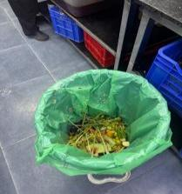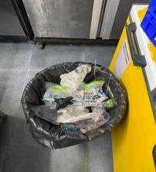
2  ref 12 | Illness  Both | No unwell staff on duty; cuts and wounds covered with a waterproof dressing.  How to verify: Look at the staff's hands — if there is a plaster, is it waterproof and coloured so it is visible? Ask the newest member what they do if they have diarrhoea or fever; the answer tells you whether the rule is real or only on paper. | ★  4 | Compliant
B. Kitchen Area
3  ref 13 | Layout  Both | Enough room to work, clean and maintain, and a design that keeps dust, waste and pests out.  How to verify: Find the spot where two people carrying hot pans have to pass each other, and the corners a mop cannot reach. | 2 | Compliant
4  ref 14 | Construction  Both | Internal construction and fittings made of non-toxic, non-absorbent, smooth and cleanable material.  How to verify: Run your hand along the prep counter and shelves. Wood, rust and peeling laminate are all findings. | 2 | Compliant
5  ref 15 | Flooring  Both | Floor non-slip, sloped towards the drain, coving at the wall-floor joint; no cracks or broken tiles.  How to verify: Walk the whole floor including under the racks. Pour a mug of water at the lowest point and see where it goes. | 2 | Compliant
6  ref 16 | Segregation  Both | Raw and cooked / ready-to-eat areas separated; veg and non-veg separated in both prep and storage.  How to verify: Colour-coded boards and knives should be in use, not lying in a drawer. Check the chiller shelves too. | ★  4 | Compliant
7  ref 17 | Ventilation  Both | Adequate ventilation and an exhaust over the cooking line; no condensation or grease dripping onto food.  How to verify: Tissue test at the edge of the hood. Check the duct joints and the ceiling above the range. | 2 | Compliant
8  ref 18 | Drainage  Both | Drainage adequate, trapped and covered, flowing away from the food area; no cross-connection with potable water.  How to verify: Look during the peak washing period, not at 4 pm. Smell at floor level for dry traps. | 2 | Compliant
9  ref 19 | Handwashing  Both | A dedicated handwash basin at the entrance to the food area, with soap, running water and a means of drying hands.  How to verify: Turn the tap on. A sink where vegetables are washed is not a handwash sink. | 2 | Compliant
10  ref 20 | Temperature control  Both | Enough chilling, freezing and hot-holding capacity for the volume handled, each with a working thermometer.  How to verify: Count the units against peak volume. An uncalibrated thermometer proves nothing. | ★  4 | Compliant
11  ref 21 | Equipment  Both | Equipment of food-grade material, designed to be cleanable, in sound condition; measuring devices calibrated.  How to verify: Look under the prep tables and behind the equipment. Ask for the calibration record for the probe and the scale. | 0 | Major | Weighing scale calibration is not being done.
12  ref 22 | Receiving  Both | Incoming goods checked and recorded — condition, temperature, date, vehicle cleanliness; rejections recorded too.  How to verify: A register with no rejection ever recorded usually means nobody is checking. | 0 | Major | Dates are not being checked on incoming goods.
13  ref 23 | Unsafe food  Both | Nothing expired, undated, unlabelled or visibly unsafe anywhere on the premises.  How to verify: Open the back row of every shelf and the bottom of every freezer basket. That is where it hides. | ★  0 | Major | 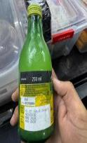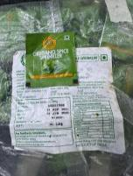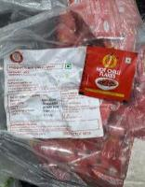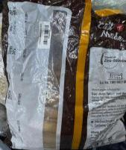
14  ref 24 | Stock rotation  Both | FIFO followed; every stored item marked with the receipt or prep date and a use-by date.  How to verify: Pick five containers at random. An unlabelled container is an undated container. | 0 | Major | 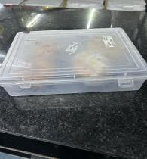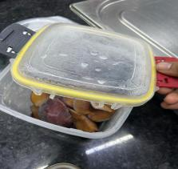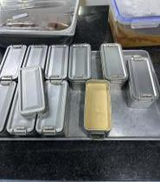
15  ref 25 | Storage  Both | Storage at least 15 cm clear of the floor and away from the wall; nothing stored under a toilet, a passage or a sink.  How to verify: Look under the lowest rack and behind the doors. | 2 | Compliant
16  ref 26 | Storage  Both | Raw and cooked separated; cooked and ready-to-eat above raw; everything in covered containers.  How to verify: Open the chiller and read the order of the shelves. Raw chicken above cooked rice is an immediate finding. | ★  4 | Compliant
17  ref 27 | Cold chain  Both | Chillers at 5 °C or below, freezers at −18 °C or below; logged at the set frequency, with action taken on exceptions.  How to verify: Probe it yourself and compare with today's log. A gap between the probe and the log is two findings, not one. | ★  0 | Major | No temperature log is being kept.
18  ref 29 | Thawing  Both | Thawing only under refrigeration, under running potable water, or in a microwave — never out in the open.  How to verify: Look at the sink and the back counter during morning prep. This is a prep-time check, not a paper one. | 2 | Compliant
19  ref 32 | Additives  Both | Only approved additives and colours, within limits; declaration and the supplier's COA on file.  How to verify: Look for an unlabelled packet of colour in the spice store. This one carries criminal liability. | ★  4 | Compliant
20  ref 34 | Chemicals  Both | Cleaning chemicals and pesticides kept away from food, clearly labelled, in a lockable place.  How to verify: A sanitiser bottle on the prep shelf is not convenience, it is an adulteration risk. | ★  4 | Compliant
21  ref 35 | Packaging  Both | Food-contact packaging food grade, with the supplier certificate on file; not reused for another purpose.  How to verify: Look at what the oil tins and paint buckets are being used for round the back. | 2 | Compliant
22  ref 36 | Labelling  CPK | Packed items labelled as the Labelling & Display regulations require — name, ingredients, allergens, veg / non-veg mark, packing date, use-by, FSSAI number, net weight.  How to verify: Take one packed tray off the dispatch rack and check every point against the rule. | ★  0 | Major | Labels are not being applied.
23  ref 38 | Transport  CPK | Vehicle food grade, clean and insulated; the cold chain held, with temperature recorded at dispatch and on arrival.  How to verify: Open the vehicle. Probe one box on arrival at the outlet and compare it with the dispatch slip. | ★  4 | Compliant
24  ref 39 | Sanitation  Both | Food-contact surfaces cleaned and sanitised between raw and cooked work; an approved sanitiser at the correct strength.  How to verify: Watch the sanitiser being made up. Check the dilution against the label, and whether there are test strips. | ★  4 | Compliant
25  ref 40 | PPE  Both | Aprons, gloves and headgear issued, in good condition, and changed at the right times.  How to verify: Gloves that have not been changed all morning are worse than no gloves at all. | 2 | Compliant
C. Whole Premises and Documentation
26  ref 41 | FSSAI licence  Both | FSSAI licence valid, of the correct category, carrying this unit's address, and displayed where it can be seen.  How to verify: Read the licence yourself: validity date, category, address. A head-office licence does not cover this kitchen. | ★  4 | Compliant
27  ref 44 | Display  Both | Food Safety Display Board, hygiene rating certificate (if held), no-smoking and handwashing notices put up.  How to verify: Walk the guest area and the kitchen entrance. A board behind a rack does not count as displayed. | 0 | Major | Food Safety Display Board not put up; no-smoking notice not put up.
28  ref 45 | Construction  Both | No plaster or paint flaking from walls, ceilings or doors; no condensation; no particles falling.  How to verify: Torch the ceiling corners and behind the dishwash. Look directly above open food. | 2 | Compliant
29  ref 46 | Lighting  Both | Enough light to work by; lights above open food shatterproof or covered.  How to verify: Look up over every open-food surface. A bare tube above a prep table is a finding. | 2 | Compliant
30  ref 47 | Water  Both | Adequate supply of potable water; water in contact with food potable; lab report within the required period.  How to verify: Check the report date, the parameters tested, and that the sample point is this unit. | ★  0 | Major | No lab report.  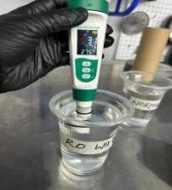
31  ref 51 | Cleaning system  Both | Cleaning schedule up to date and signed; dispatch log with temperatures (CK outlets).  How to verify: Take one line off the schedule and touch that surface yourself — signed but greasy is a finding, not a pass. For CPK/CK, check whether last week's dispatch slips carry temperatures. | 0 | Major | Nothing has been put up at all.  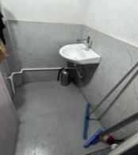
32  ref 52 | Pest control  Both | Pest control by a licensed agency at a set frequency; bait map and service records on file; no signs of pests.  How to verify: Torch under the equipment and along the wall-floor joint first, then look at the records. | ★  0 | Major | No record.
33  ref 53 | Medical fitness  Both | An annual medical fitness certificate for every food handler.  How to verify: Count the certificates against today's staff list, not last year's. Check the dates. | ★  4 | Compliant
34  ref 54 | Appearance  Both | Clean uniform, head covered, no jewellery, nails short and unpainted, no watches in the food area.  How to verify: Not a team lined up for you — look at hands and hairlines during service. | 2 | Compliant
35  ref 55 | Handwashing  Both | Hands washed at the designated point and at every change of task; cooked or ready-to-eat food never touched with bare hands.  How to verify: Stand quietly at the pass for five minutes. This one is to be watched, not asked. | ★  4 | Compliant
36  ref 56 | Conduct  Both | No smoking, spitting, eating or chewing in the food area; notices displayed and followed.  How to verify: Not the main kitchen — check the back staircase and the store room. | 1 | Minor | The notices are not put up.
37  ref 57 | FoSTaC  Both | One FoSTaC-trained Food Safety Supervisor for every 25 food handlers, with a valid certificate.  How to verify: Count the handlers, count the certificates, check the expiry. This is a licence condition and it blocks renewal. | ★  0 | Major | No certificate.
38  ref 58 | Training  Both | Induction and refresher food safety training for all handlers; records with date, topic and signature.  How to verify: Take one name off the training list and ask that person what they were taught. | 1 | Minor | No record.
39  ref 59 | Records  Both | Records available and kept for one year or the shelf life, whichever is longer — temperature, cleaning, pest, water, oil, medical, training, supplier.  How to verify: Ask for one specific date three months ago and see how long it takes to produce it. | ★  0 | Major | No pest control record, no water report, no training record.
40  ref 60 | Regulator follow-up  Both | Findings from the last FSO inspection or improvement notice closed within the deadline, with evidence.  How to verify: Ask for the last inspection report. Even 'they have never come' has to be evidenced by the file. | 0 | Major | Expired stock, records, training and certificate — all outstanding.
Score and Grade
Section | Available marks | Obtained marks | %
A. Service Area | 6 | 4 | 66.7%
B. Kitchen Area | 66 | 48 | 72.7%
C. Whole Premises and Documentation | 44 | 20 | 45.5%
Total | 116 | 72 | 62.1%

Conclusion
• Overall standing — 72/116 (62.1%), Needs Improvement. By section: A Service Area 66.7% (Needs Improvement), B Kitchen Area 72.7% (Needs Improvement), C Whole Premises and Documentation 45.5% (Non-Compliance).
• Close the ★ critical lines first — 7 ★ critical lines are rated Major (lines 13, 17, 22, 30, 32, 37, 39) and they carry 28 marks between them. Closing those 7 alone takes the score to 100/116 (86.2%), inside the Satisfactory band. 80% needs 93 marks; the unit has 72, so it is 21 short.
• Of the 14 Major lines, 11 are paperwork and 3 are physical — paperwork: lines 11, 12, 14, 22, 27, 30, 31, 32, 37, 39, 40 (Equipment · Receiving · Stock rotation · Labelling · Display · Water · Cleaning system · Pest control · FoSTaC · Records · Regulator follow-up). The work is being done but no record exists, and that set can be closed in a week or two. Physical: lines 1, 13, 17 (Waste · Unsafe food · Cold chain) — real work on site, of which the expired stock on line 13 (★) is the most urgent.

